 |  |  |  |  | 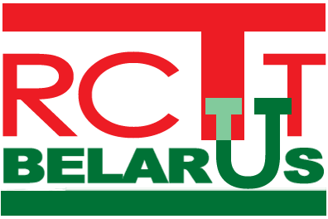

The State Committee on Science and Technology of the Republic of Belarus
The National Academy of Sciences of Belarus
The National Library of Belarus
The United Nations Industrial Development Organization
The United Nations Development Programme
The Republican Centre for Technology Transfer
The Institute of Economics under the National Academy of Sciences of Belarus

A G E N D A
of
International Seminar on Technology Foresight
for the Republic of Belarus

27 March, 2009

Start | End | Event/item
10:00 | 10:15 | The welcome address by Mr. Motulskiy, Director of the National Library of Belarus;  Opening statement “Technology Foresight as a Tool for Integration into the World Community” by Mr. Vityaz , First Deputy Chairman of the Presidium of the National Academy of Sciences of Belarus
10:15 | 12:00 | Report “Technology Foresight Surveys in Russia. Theory and Practice” by Mr. Alexander Sokolov, Director of the Foresight Centre with the Higher School of Economics (Russia)
12:20 | 13:00 | Report “Prospects for Application of the Technology Foresight Approaches in the System of Long-Term Development Planning in Belarus” by Mr. Markov, Deputy Director of the Institute of Economics under the National Academy of Sciences of Belarus
13:00 | 13:40 | Report “Technology Foresight Surveys for the Republic of Belarus. Aims, Goals, Organizational Arrangements” by Mr. Goncharov, Head of the Department for Innovative Development of Economy, the Institute of Economics under the National Academy of Sciences of Belarus
14:10 | 15:00 | Report “Formation Principles of the Expert Pool for Technology Foresight Surveys in Belarus” by Mr. Kobyak, Deputy Director of the Minsk Research Institute of Socioeconomic Problems, Mr. Shablovskiy, Principal Researcher of the Institute of Language and Literature under the National Academy of Sciences of Belarus
15:00 | 15:50 | Report “Capacities of RCTT for Assistance in Preparing and Organizing the Technology Foresight Survey in Belarus” by Mr. Uspenskiy, Director of the Republican Centre for Technology Transfer
16:20 | 16:40 | The roundtable meeting for the participants to speak out, exchange their opinions, consider and coordinate the principles for the would-be interactions between the participants of the seminar and the experts.
16:40 | 17:00 | The final session of the seminar. Individual consultations with the Working Group.
17:00 | 18:00 | A meeting of the Working Group on organization of technology foresight in Belarus.

