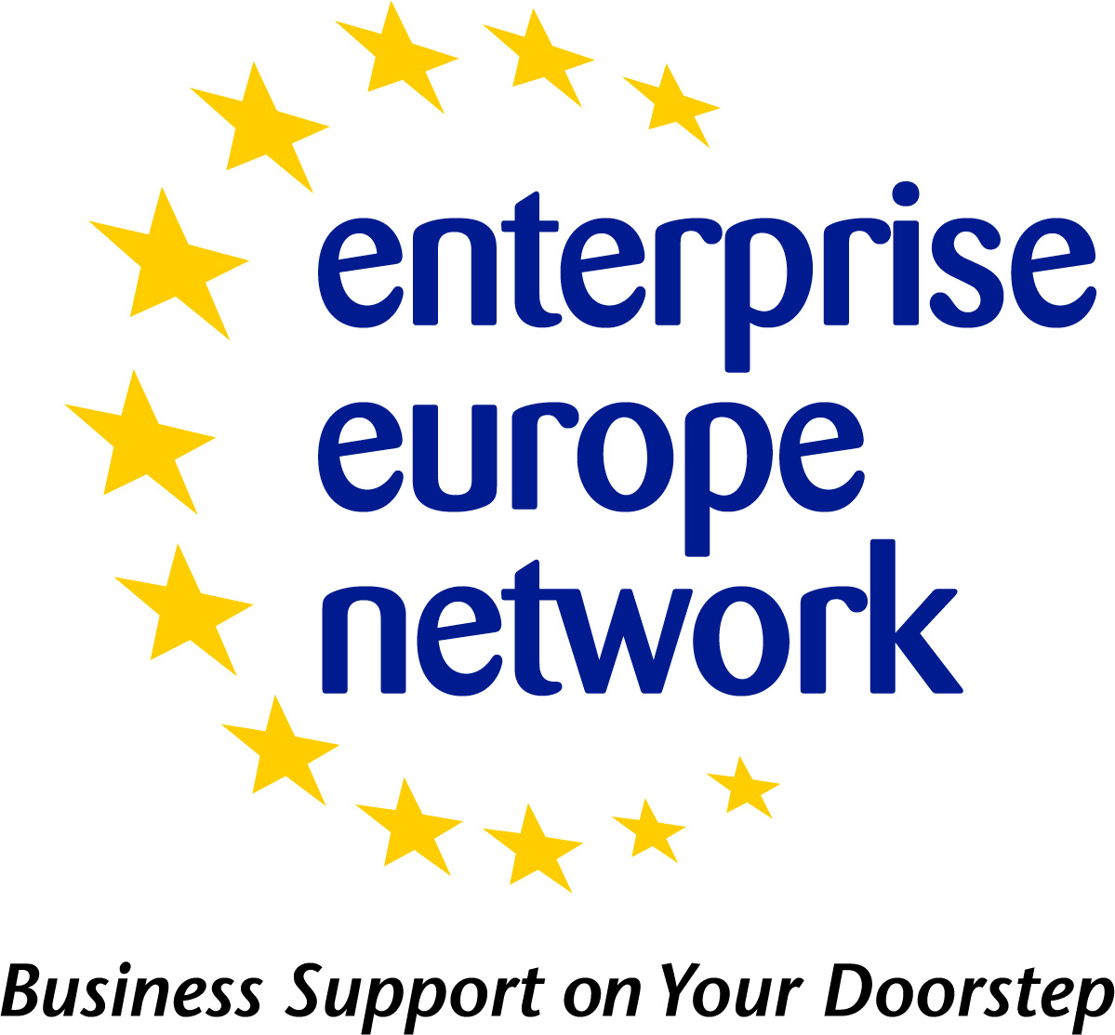 | Business Request - Profile Template  Updated - July 2014
 | European Commission
Business Request Profile
The following table can be used as a template for drafting a Business Request. Please be sure to refer to the Profile Drafting Guidelines for what information you should include in each field.
Please note:
- Fields marked with asterisk (*) are mandatory
- Fields that can be ticked should only have one selection when drafting the profile unless specified under the field title.

FIELD | Field to be populated
Title *
Internal Reference
Summary *
(1-500 characters)
Stage of Development | Already on the market  Available for demonstration  Concept Stage  Field Tested / Evaluated  Project Already Started  Project in Negotiations - Urgent  Proposal under development  Prototype available for demonstration  Under development / lab tested
Comments regarding Stage of Development
Description *
(100-4000 characters)
Technical Specification or Expertise Sought *
IPR Status  Note: Multiple fields can be selected. | Copyright  Design Rights  Exclusive Rights  Granted patent or patent application essential  Other (registered design, plant variety, etc.)  Patent(s) applied for but not yet granted  Patents granted  Secret Know-how  Trade Marks
Comments Regarding IPR Status
Technology Keywords
Market Keywords *
Responsible * | In Merlin, select who from your organisation will be responsible for this profile
Sector Group | Auronautics & space  Agrofood  Automotive, transport and logistics  Bio Chem Tech  Creative Industries  Environment  Healthcare  ICT Industry and Services  Intelligent Energy  Maritime Industry and Services  Materials  Nano – and Microtechnologies  Services and Retail  Sustainable Construction  Textile and Fashion  Tourism and Cultural Heritage  Women entrepreneurship
Restrict Dissemination to specific countries
Type and Size of Client * | Industry SME <= 10  Industry SME 11-49  Industry SME 50 – 249  Industry 250-499  Industry >500  Industry MNE >500  Inventor  Other  R&D institution  University
Year Established *
NACE keywords *
Turnover *  (Euros – Millions) | <1M  1-10M  10-20M  20-50M  50-100M  100-250M  250-500M  >500M
Already Engaged in Trans - national Cooperation? | Yes (In Merlin tick the check box for yes)  No
Additional Comments
Certification Standards
Languages Spoken *
Client Country
Type and Role of Partner Sought *
Profile is Opened for Expressions of Interest? | Yes (In Merlin tick the check box for yes)  No
Type and Size of Partner Sought  Note: Multiple fields can be selected. | SME < 10  SME 11-50  SME 51 – 250  251-500  >500  MNE >500  Inventor  R&D institution  University
Type of Partnership Considered *  Note: Multiple fields can be selected. | Acquisition Agreement  Commercial Agency Agreement  Distribution Services Agreement  Financial Agreement  Franchise Agency Agreement  Joint Venture Agreement  License Agreement  Manufacturing Agreement  Outsourcing Agreement  Reciprocal production  Services Agreement  Subcontracting
Attachments | To be added in Merlin

