 | 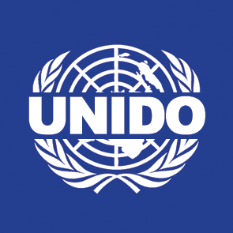 | 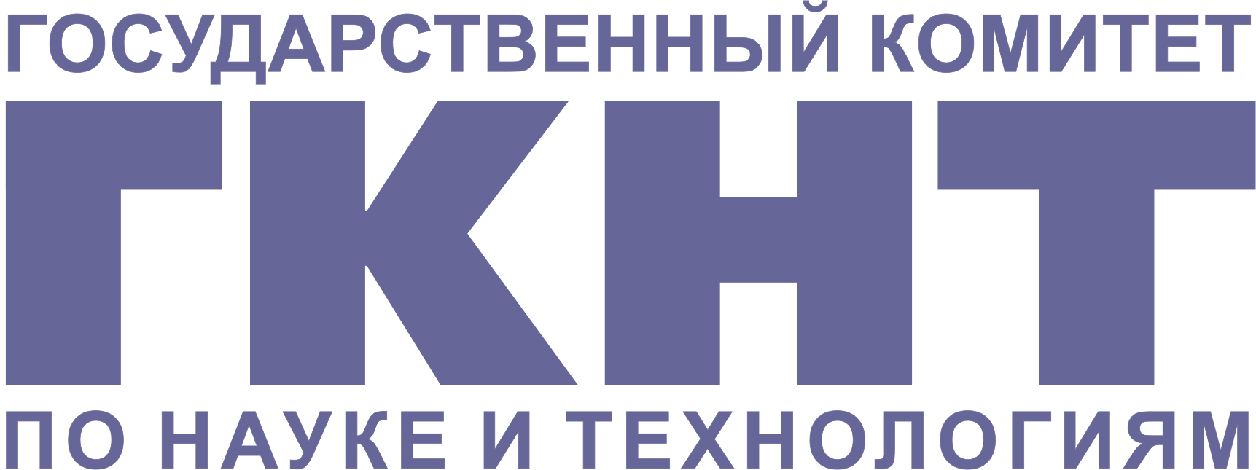 | 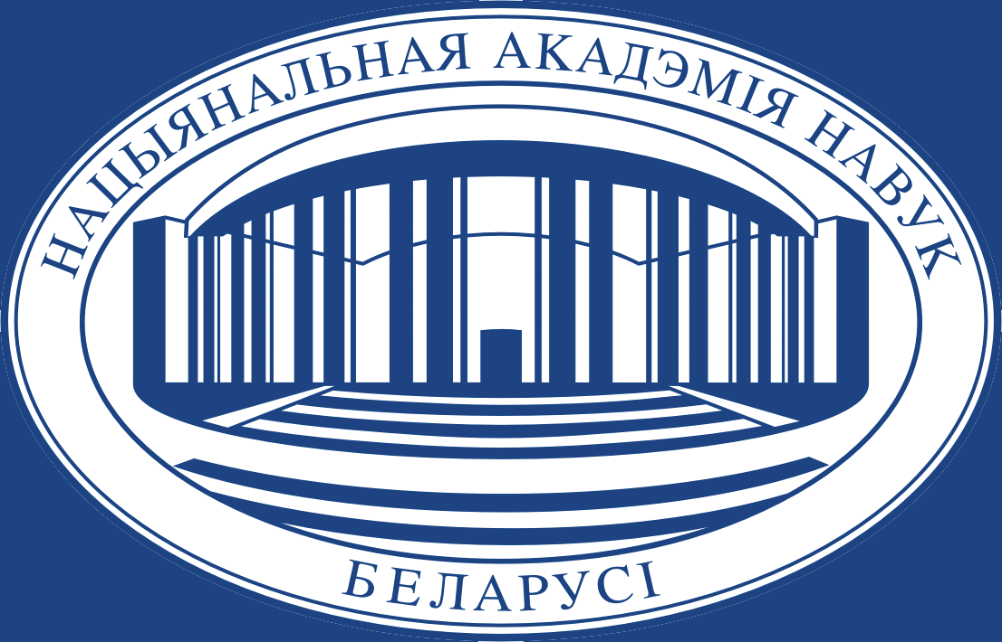 | 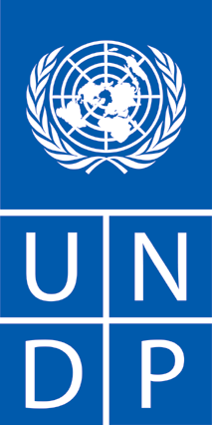 | 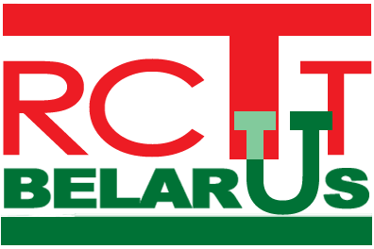

WIPO-UNIDO National seminar on managing
INTELLECTUAL PROPERTY of small and medium-sized enterprises (smes) IN THE “BELARUS HIGH TECHNOLOGIES PARK”
jointly organized by
World Intellectual Property Organization (WIPO)
United Nations Industrial Development Organization (UNIDO)
United Nations Development Programme (UNDP)
State Committee for Science and Technology of the Republic of Belarus (SCST)
National Academy of Sciences of Belarus (NASB)
High Technologies Park (HTP)
Republican Centre for Technology Transfer (RCTT)

23 – 25 January 2007
Minsk, Republic of Belarus

PROGRAM

Tuesday, January 23, 2007

8.30 – 9.30 Registration

9.30 – 10.00 Opening Ceremony

Welcome addresses by:

Mr. Vladimir Nedzilko, First Deputy Chairman, The State Committee on Science and Technology of the Republic of Belarus, Minsk, Belarus

Mr.Pyotr Vityaz, First Deputy Chairman, Presidium of the National Academy of Sciences of Belarus, Minsk

Valeri Tsepkalo, Director, Administrative Board of the High Technologies Park, Minsk

Mr. Vladimir Kozharnovich, Program Manager, Investment and Technology Promotion Branch, United Nations Development Organization (UNIDO), Vienna International Centre, Austria

Mr. Guriqbal Singh Jaiya, Director, Small and Medium-Sized (SMEs) Enterprises Division, World Intellectual Property Organization (WIPO), Geneva, Switzerland

10.00 – 10.30 Theme 1 INTELLECTUAL PROPERTY PROTECTION FOR SOFTWARE AND DATABASES

Topic 1: An Overview of National and International Intellectual Property Systems and the Role of WIPO

Speaker: Mr. Guriqbal Singh Jaiya

Discussion

10.30 – 10.45 Coffee Break

10.45 – 11.45 Topic 2 Copyright Protection for Software in the Digital Environment – A General Overview

Speaker: Mr. Boris Kokin, Senior Legal Counsellor, Copyright
Law Division, WIPO

Discussion

11.45 – 12.15 Topic 3 Copyright Protection for Software in Belarus

Case Studies

Speaker: Mr. Serhei Shabeka, Head of the Copyright Protection
Department, National Center of Intellectual Property (NCIP), Minsk, Belarus

Discussion

12.15 – 13.30 Lunch

13.30 – 15.00 Topic 4 Patent Protection for Software and for Software Based Business Methods – A General Overview and Comparison between European and United States Approaches

Speaker: Mr. Olivier Gabriel Michel Sacroug, specialist of KATZAROV SA, Geneva Switzerland

Discussion

15.00 – 15.30 Topic 5 Patent Protection for Software in Belarus and Eurasia – Case Studies

Speaker: Mr. Sergey Vinogradov, Patent Attorney, PAG – E – PAG, Minsk, Belarus

Discussion

15.30 – 15.45 Coffee Break

15.45 – 16.30 Topic 6 The Importance of Trade Secrets for Software Companies

Speaker: Mrs. Lien Verbauwhede, Consultant, SMEs Division, WIPO

Discussion

16.30 – 17.15 Topic 7 Database Protection

Speakers: Prof. dr. Marie-Christine Janssens, Catholic University of Leuven (KULeuven), Belgium

Discussion

Wednesday, January 24, 2007

9.00 – 9.30 Theme 2 Practical Intellectual Property Issues in Relation to the Business of Software Development

Topic 8 Marketing Software Products: The Importance of Trademarks and Industrial Designs - Case Studies

Speaker: Mr. Guriqbal Singh Jaiya

Discussion

9.30 – 10.15 Topic 9 Dealing with Software Piracy

Speaker: Mr. Pravin Anand, Attorney, Anand & Anand, New Delhi, India

Discussion

10.15 – 10.30 Coffee Break

10.30 – 11.15 Topic 10 Enforcement of Intellectual Property Rights in Software in Belarus

Speaker: Mr. Ihar Kavalevich, Head of Auditor’s Services, National Center of Intellectual Property (NCIP), Minsk, Belarus

Discussion

11.15 – 11.45 Topic 11 Digital Rights Management (DRM) and Software Products

Speaker: Mr. Olivier Gabriel Michel Sacroug

Discussion

11.45 – 12.30 Topic 12 Ownership of Intellectual Property Rights in Software (including: Collaborative Development of Software)

Speaker: Mr. Boris Kokin

Discussion

12.30 – 13.30 Lunch

13.30 – 14.15 Topic 13 Fair Use and Software Reverse Engineering

Speaker: Prof. dr. Marie-Christine Janssens

Discussion

14.00 – 14.45 Topic 14 Intellectual Property Audit and Due Diligence

Speaker: Mr. Guriqbal Singh Jaiya

Discussion

14.45 – 15.45 Topic 15 Practical Issues in Licensing of Software (including Intellectual Property Issues Related to Open Source Software)

Speakers: Mr. Mr. Olivier Gabriel Michel Sacroug
Mr. Pravin Anand

Discussion

15.45 – 16.15 Topic 16 Intellectual Property Issues in a Company Website

Speaker: Mrs. Lien Verbauwhede

Discussion

16.15 – 16.30 CLOSING CEREMONY

Thursday, January 25, 2007

9.00 – 12.00 Roundtable Discussions

Meeting the Intellectual Property Needs of Small and Medium-Sized Enterprises in a High-Tech Park (including Patent Information Services)

Best Practices in Securing Intellectual Property Rights in Technology Transfer and Commercialization Processes

12.00 – 13.30 Lunch

[End of document]

